# Target Metrics

Overall - Accuracy: 0.8200, Precision: 0.8268, Recall: 0.8200, F1: 0.8198

Class-specific metrics:

Carbon neutral(ity) - Precision: 0.8095, Recall: 0.6800, F1: 0.7391

Emissions reduction target - Precision: 0.8077, Recall: 0.8400, F1: 0.8235

Net zero - Precision: 0.7333, Recall: 0.8800, F1: 0.8000

No target - Precision: 0.9565, Recall: 0.8800, F1: 0.9167

# Year Metrics

Overall - Accuracy: 0.8200, Precision: 0.8418, Recall: 0.8200, F1: 0.8257

Class-specific metrics:

2020 - Precision: 0.0000, Recall: 0.0000, F1: 0.0000

2022 - Precision: 0.0000, Recall: 0.0000, F1: 0.0000

2025 - Precision: 0.5000, Recall: 0.6000, F1: 0.5455

2030 - Precision: 0.7586, Recall: 0.8800, F1: 0.8148

2031 - Precision: 0.0000, Recall: 0.0000, F1: 0.0000

2031-32 - Precision: 0.0000, Recall: 0.0000, F1: 0.0000

2032 - Precision: 0.0000, Recall: 0.0000, F1: 0.0000

2033 - Precision: 0.0000, Recall: 0.0000, F1: 0.0000

2035 - Precision: 0.8333, Recall: 1.0000, F1: 0.9091

2040 - Precision: 1.0000, Recall: 0.8000, F1: 0.8889

2050 - Precision: 0.9091, Recall: 0.7407, F1: 0.8163

No target - Precision: 0.9600, Recall: 0.9600, F1: 0.9600

# Other Metrics

Quote Accuracy: 0.7200

Overall Accuracy: 0.7500

Valid XML Percentage: 1.0000

# Confusion Matrices

Target Confusion Matrix:

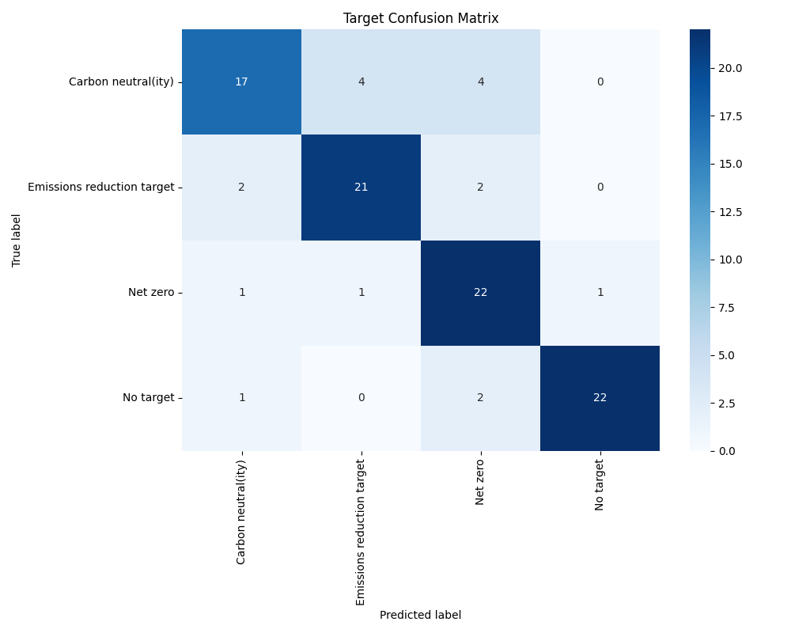

Year Confusion Matrix:

